Calculating Stream Gradient
A stream's gradient is the slope of a stream, or its change in elevation over a given horizontal distance. More simply, the gradient is the distance the stream falls vertically from one point on the landscape to another. To learn more about the gradient and how to calculate it, watch this Youtube video.
https://www.youtube.com/watch?v=ykeCKm9JqSA
Streams are like lines that flow across the landscape, and a stream's gradient is the slope of the flowing stream. To calculate the stream gradient, you simply identify the change in elevation of a stream and divide this change in elevation by the measured horizontal distance over which the stream has flowed.

Schematic Stream Examples
Below are two schematic drawings of streams flowing across two contour lines (changes in elevation) from Point A to Point B. Calculate the gradients of each of these streams and add the answer to the attached answer worksheet.

Example A
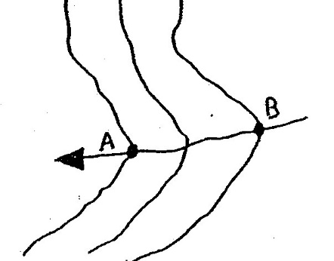
The contour lines are the vertical lines and the stream is the line running between A and B. The contour lines tell you the change in elevation. Every contour line crossed is one contour interval of elevation. In this example, the contour interval is 25 m and two contour lines are crossed.
The horizontal distance is based on the map scale. The map scale in this example is 1:15000, which means that every 1 cm on the map is 15,000 cm in real life. In this example, the length of the line running between A and B on the map is 2 cm.
Answer the following questions on the attached answer worksheet.
a) What is the change in elevation in meters between Points A and B?
b) What is the horizontal distance between Points A and B in kilometers?
c) The stream gradient is the change in elevation divided by the horizontal distance. What is the stream gradient in m/km?

Example B
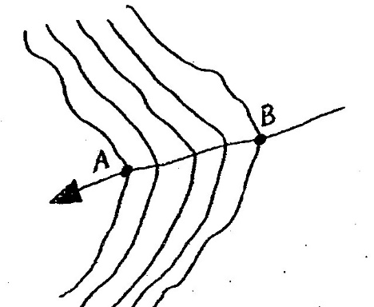
In this example the contour interval is 10 m and the map scale is 1:5000. The length of the line running from Point A to Point B is 2 cm.
Answer the following questions on the attached answer worksheet.
a) What is the change in elevation in meters between Points A and B?
b) What is the horizontal distance between Points A and B in kilometers?
c) The stream gradient is the change in elevation divided by the horizontal distance. What is the stream gradient in m/km?

Philipp, Mississippi Quadrangle Map
The image below is a section of a contour (elevation) map entitled the Philipp, Mississippi Quadrangle map. The river depicted is a section of the Tallahatchie River just north of the town of Philipp. The distance between the "mile 210" and "mile 215" points following the wide meandering oxbow is 8.25 miles. The distance between these two points following the Pecan Point Cutoff, which is an artificial cutoff that has shortened the length of the stream, is 5.05 miles. Using this information and what you know about stream gradients, answer the following questions on the attached answer worksheet.
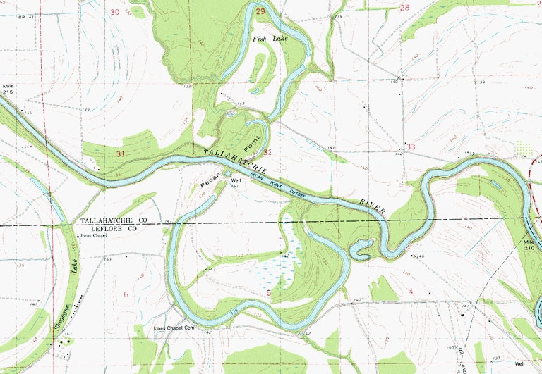
a) How many miles is saved by the cutoff?
b) If the elevation is 119 ft at mile 215 and 116 ft at mile 210, the gradient between these two points using the oxbow meander is how many ft/mi?
c) What is the gradient using the Pecan Point Cutoff?

